Key
Parts of Speech
- Noun = N
- Verb = V
- Adjective = Adj
- Adverb = Adv
- Determiner = Det
- Preposition = Prep
- Pronoun = Pro
- Interjection = Intj
- Conjunction = Conj
- Relativizer = Rel
- Complementizer = Comp
Phrase Types
- Noun Phrase = NP
- Verb Phrase = VP
- Adjective Phrase = ADJP
- Adverb Phrase = ADVP
- Prepositional Phrase = PP

Roles
- Subject = Subj
- Predicate = Pred
- Adverbial = Advl
- Subject Complement = SC
- Direct Object = DO
- Indirect Object = IO
- Object Complement = OC

Clauses
- Sentence = S
- Independent Clause = IC
- Dependent Clause = DC
- Relative Clause = RC
- Complement Clause = CC
Notes
- Always include a phrase level for nouns, verbs, adjectives, adverbs, and prepositions
- You do not need to include the “roles” in your diagram unless you are specifically asked.
- Label Possessive Nouns as Nouns with an NP even though they appear in the determiner position
- Some parts of speech fill the role for other parts of speech. For instance, a verb can take a noun position and serve as a subject. In this case, either label is ok on the diagram, as long as the lines are in the right position.

Noun Phrases
- Determiner
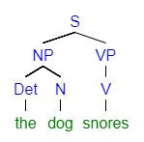
- Adjective in a Noun Phrase
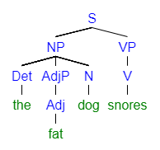
- Prepositional Phrase in a Noun Phrase
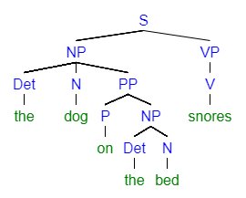
- Adverb in an Adjective Phrase
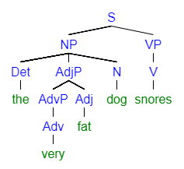

Verb Phrases
- Adverb in a Verb Phrase
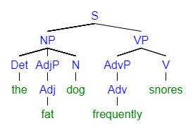
- Prepositional Phrase in a Verb Phrase
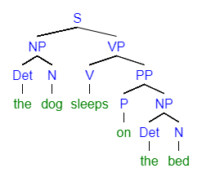
- Adverb (extra adverb) in and Adverb Phrase
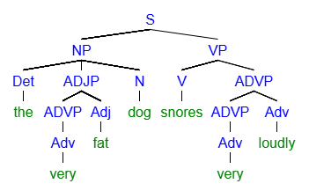
- Everything in Unit One
